Join us for an Information-Packed Workshop
The workshop will “bridge the gap” between planners and communities, by introducing them to available resources for community planning projects and activities. The workshop will provide an explanation of community planning, and an understanding of how it can help communities achieve their goals. The program will include hands on activities that will engage participants in strategically planning for communities. Participants will leave the workshop with a better understanding of how to initiate the development of a plan and how to get resources and experts to help them.
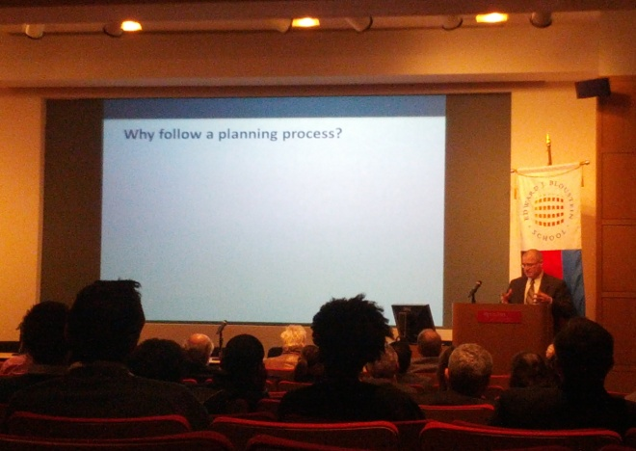
HIGHLIGHTS INCLUDE:
- An introduction to community planning from local experts
- Key steps to start the planning process in your community.
- Strategies for involving the community in the planning process.
- Insight for partnering with local officials.
- Participation in real community planning case studies.
- Sources for funding for community planning.

Who should attend? This workshop is designed for all stakeholders in a community… community groups, community based organizations, municipal planners, and community planning consultants.

THIS EVENT IS PROUDLY SPONSORED BY:

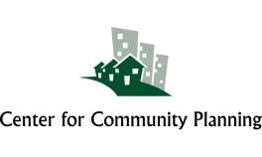
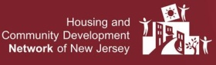
When: March 6, 2014 Time: 8:30 am – 3:00 pm
Date to be Confirmed
Where: North Jersey Transportation Planning Authority
1 Newark Center, 17th Floor
Newark, NJ
Directions: http://www.njtpa.org/About-NJTPA/Directions.aspx
Cost: $35 includes breakfast, lunch, and Materials
Registration will begin February 1, 2014

